System Requirements Statement (SRS) –

BikeLeLo

**Table of contents:**

1. **Introduction 3**

2. **Functional Requirements 4**

2.1 Index Module **5**

2.2 Registered-User Module **8**

2.3 Showroom Module **13**

2.4 Admin Module **18**

**2.5 Use Case Diagrams 20**

THIS DOCUMENT CONTAINS 23 NUMBERED PAGES

# Introduction

This document explains the system requirements and scope for developing BikeLeLo System.

BikeLeLo System could divide the four main modules, Admin Module, Showroom Module, Non Registered User Module and Registered User Module.

This document describes the system requirement of the Account part.

# Functional Requirements

The BikeLeLo System has four modules which are divided into 28 processes described below.

| **No** | **BRS requirement ID** | **Description** |
| --- | --- | --- |
| **2.1** | **Non-Registered User Module** | |
| **2.1.1** | **F1** | **Search Bikes** |
| **2.1.2** | **F2** | **Compare Bikes** |
| **2.1.3** | **F3** | **Create New Account for user** |
| **2.2** | **Registered User Module** | |
| **2.2.1** | **F11** | **Login** |
| **2.2.2** | **F12** | **Update Profile** |
| **2.2.3** | **F13** | **Search Bikes** |
| **2.2.4** | **F14** | **Compare Bikes** |
| **2.2.5** | **F15** | **Book Bike** |
| **2.2.6** | **F16** | **View Bookings** |
| **2.2.7** | **F17** | **Cancel Booking** |
| **2.2.8** | **F18** | **Logout** |
| **2.3 Showroom Module** | | |
| **2.3.1** | **F21** | **Login** |
| **2.3.2** | **F22** | **Update Profile** |
| **2.3.3** | **F23** | **Publish Bikes** |
| **2.3.4** | **F24** | **Update Bikes** |
| **2.3.5** | **F25** | **Delete Bikes** |
| **2.3.6** | **F26** | **Update Booking Status** |
| **2.3.7** | **F27** | **Logout** |
| **2.4 Admin Module** | | |
| **2.4.1** | **F31** | **Login** |
| **2.4.2** | **F32** | **Create Showroom Account** |
| **2.4.3** | **F33** | **Delete Showroom Account** |
| **2.4.4** | **F34** | **Delete User Account** |
| **2.4.5** | **F35** | **Generate Sales Reports** |
| **2.4.6** | **F36** | **Logout** |

## Non-Registered User Module

* This is the home page for the BikeLeLo System.
* The “Side Menu” provides the items described as below.

1. A trigger to Search Bikes

2. A trigger to Compare Bikes

3. A trigger to create new Account for user

* + 1. Search Bikes
* In this feature user can search bike through search bar with provided filters.
  + Bike Category
    - With Gear Bike
    - Without Gear Scooters
    - Electric Bikes and Scooters
  + City Location
    - Pune
    - Nagpur
    - Mumbai
    - Kolhapur
    - Satara
    - Ahmednagar
  + Company Name
  + Price Range
* Once user select specific filters, list of available bikes will be populated on page.
* There are “Compare” and “View More” triggers available under each bike data,
* If user opted for Compare, then the bike will be added to compare list and user will get another list of bikes from same category from which user can select another bike for comparison.
* If user opted for view more, then it will be redirected to bike description page where all the detailed specification and other necessary information is available. Also, user can get on-road price for specific city by selecting city from available drop down list. And then user will get trigger to book bike.
* When user opted for the Book, then it will be redirected to login page as only registered users can book the bike.
  + 1. Compare Bikes
* In this feature, user can compare between two bikes chosen by user.
* This will be shown in two separate tabular structures with specific bike information.
* After comparing two bikes user will have redirection to booking bike.
* When user opted for the Book bike, then it will be redirected to login check page as only registered users can book the bike. If user is not logged in then login form will be populated.

### 2.1.3 Account Creation Process

* In BikeLeLo System, only end user can register themselves. For Showroom, admin will be responsible for creating an account.
* Non-Registered users can only search and compare the bikes.
* BikeLeLo System compels users to create an account to book bikes. So, BikeLeLo System should provide the function which allows users to create new accounts.
* When user creates new account, the function demands following information :

1. Login information

2. Contact Details

3. Security Question Information

* **Login information:**

The Login information consists of some items described as below.

1. UserID (Same as E-mail ID)
2. Password
3. First Name
4. Last Name
5. E-mail address
6. Date of Birth
   * All items are compulsory.
   * UserID

* The UserID should be unique. If the UserID matches with previous UserID then the provided UserID should not be registered.
  + Password
* The Password has constraints which makes the Password consists of more than or equal 8 and less than or equal 12 characters including characters described below.

1. Numeric figure (at least one)
2. Capital alphabet (A-Z)(at least one)
3. Small alphabet (a-z)(at least one)
4. Special character (#, $, %, &, @) (at least one)

* The Password is masked by dummy characters. The re-entering Password is demanded.
* The Password must be encrypted in the BikeLeLo System.
* **Contact Details**
  + The Contact Detail consists of items described as below.
* Permanent Address
* Contact Number
  + All items are compulsory.
  + Permanent Address
* Permanent Address should be filled.
* The state should be selected from options.
* **Security Question information**
* The Security Question information is needed when a user loses their Password. This information consists of two items described below.
* Selected Question
* Answer
* Hint (Not similar as Answer)
  + All items are compulsory.
  + Some questions which are difficult to answer for anyone else are prepared in advance. E.g. which colour do you like most?
  + A question should be selected from options by the user, and the Answer and hint is registered by the user.

## Registered User Module

* Registered-user is the main user of the system who wants to buy the bike.
* They are also able to search and compare various bikes.
* The “Side Menu” provides the items described as below after login.

1. A trigger to Login
2. A trigger to Update Profile
   * + View Profile
     + Edit Profile
     + Change Password
3. A trigger to Search Bikes
4. A trigger to Compare Bikes
5. A trigger to Book Bike
6. A trigger to View Bookings
7. A trigger to Cancel Booking
8. A trigger to Logout
   * 1. Login

⮚ BikeLeLo System always compels registered users to authenticate before booking any bike.

⮚ User authentication demands UserID and Password. The UserID and the Password should be checked in two ways. If user forgets their password then forgot password link is available to reset password.

⮚ First, the UserID and the Password should exist and be corrected.

* If the UserID and the Password are not equal to what the user has registered, the user authentication cannot proceed.

⮚ Second, UserID should be available.

* The Administrator can decide whether the UserID is available or suspended – Refer to the SRS of the Admin part.
* If a user is rejected, user authentication is not provided for system user.

⮚ User account should live for so long as the duration decided by Admin.

⮚ Once the two checks are successfully completed, user is placed on a respected page.

Forgot Password

⮚ When a system user loses their Password, the recovery method should be provided by the BikeLeLo system.

The recovery method is described below.

⮚ First, a registered user enters their UserID for BikeLeLo System.

⮚ Next, the BikeLeLo System demands the Answer which has been registered while creating the account.

⮚ Only when the Answer is correct, user get the form to reset the new password.

⮚ The new password should consist of more than or equal 8 and less than or equal 12 characters including at least a numeric figure, a capital alphabet, a small alphabet, and a special character.

⮚ If the Answer is incorrect, the correct Answer is demanded from the user again for 3 times after that hint will be shown.

2.2.2 Update Profile

* View Profile
* Edit Profile
* Change Password

**View Profile**

* This page shows the user dashboard for the current user.
* All provided information will be displayed.

**Update Profile**

* The updatable items as described below.
* First Name
* Last Name
* User Phone Number
* Address
* All items are compulsory, but updating is optional if there are any corrections required.

### Change Password

* + - When a user wants to change their Password, the function will be available in BikeLeLo System.
    - Therefore, BikeLeLo System provides this function only when the user is logged in.
    - The function demands the current password and the new password.
      * Of course, the new password should consist of more than or equal 8 and less than or equal 12 characters including at least a numeric figure, a capital alphabet, a small alphabet, and a special character.
      * The current password and the new password are masked by using dummy characters.
      * The new password is demanded to enter twice to avoid a typing error.
      * The new password will not be the same as the current password.
    - Only when the current password is correct, user can change their Password.
    - When the current password is changed into a new password, BikeLeLo System compels the user to login again.
    1. Search Bikes
* In this feature user can search bike through search bar with provided filters.
  + Bike Category
    - With Gear Bike
    - Without Gear Scooters
    - Electric Bikes and Scooters
  + City Location
    - Pune
    - Nagpur
    - Mumbai
    - Kolhapur
    - Satara
    - Ahmednagar
  + Company Name
  + Price Range
* Once user select specific filters, list of available bikes will be populated on page.
* There are “Compare” and “View More” triggers available under each bike data,
* If user opted for Compare, then the bike will be added to compare list and user will get another list of bikes from same category from which user can select another bike for comparison.
* If user opted for view more, then it will be redirected to bike description page where all the detailed specification and other necessary information is available. Also, user can get on-road price for specific city by selecting city from available drop down list. And then user will get trigger to book bike.
* When user opted for the Book, then it will be redirected to login page as only registered users can book the bike.
  + 1. Compare Bikes
* In this feature, user can compare between two bikes chosen by user.
* This will be shown in two separate tabular structures with specific bike information.
* After comparing two bikes user will have redirection to booking bike.
* When user opted for the Book bike, then it will be redirected to login check page as only registered users can book the bike. If user is not logged in then login form will be populated.
  + 1. Book Bike
* On this page, user will get details of selected bike with preferred city.
* Also, In this step user need to select mode of payment.
* After selecting mode of payment, user will be redirected to final stage of booking i.e., Booking confirmation.

### View Bookings

* In this section user can see their all previous as well as current bookings.
* Also user can view their invoices details.
* Booking confirmation details
  + Date
  + Invoice Number
  + Customer Name
  + Model Name
  + Showroom Details (Including showroom name, address, contact and email of showroom)
  + Estimated delivery date by showroom
* Payment details
  + Amount
  + Mode of payment
  + Transaction Details
    1. Cancel Booking
* This shows current bike bookings that can be cancelled.
* This function enables user to cancel the booking with refund within given timeline.
* This system allows cancellation of booking with following terms:
  + 10% deduction in booking amount within 2 Days of booking.
  + After 2 days, 25% deduction in booking amount till 5th Day of booking.
  + After 5 days, 50% deduction in booking amount till 7th Day of booking.
  + After 7 days, no refund will be issued on cancellation of booking.
    1. Logout
* This will provide a trigger to logout from current session. Also, it’ll redirect to home page of the system.

#### Showroom Module

* Showroom module is for the registered showroom to publish bikes and other showroom functionalities.
* The “Side Menu” provides the items described as below.
  + - 1. A trigger to Login
      2. A trigger to Update Profile
      3. A trigger to Publish Bikes
      4. A trigger to Update Bikes
      5. A trigger to Delete Bikes
      6. A trigger to Update Booking Status
         * Booking confirm
         * Cancelled
         * Pending
         * Ready to deliver
         * Delivered
      7. A trigger to Logout
    1. Login

⮚ BikeLeLo System always compels registered users to authenticate before booking any bike.

⮚ User authentication demands UserID and Password. The UserID and the Password should be checked in two ways. If user forgets their password then forgot password link is available to reset password.

⮚ First, the UserID and the Password should exist and be corrected.

* If the UserID and the Password are not equal to what the user has registered, the user authentication cannot proceed.

⮚ Second, UserID should be available.

* The Administrator can decide whether the UserID is available or suspended – Refer to the SRS of the Admin part.
* If a user is rejected, user authentication is not provided for system user.

⮚ User account should live for so long as the duration decided by Admin.

⮚ Once the two checks are successfully completed, user is placed on a respected page.

Forgot Password

⮚ When a system user loses their Password, the recovery method should be provided by the BikeLeLo system.

The recovery method is described below.

⮚ First, a registered user enters their UserID for BikeLeLo System.

⮚ Next, the BikeLeLo System demands the Answer which has been registered while creating the account.

⮚ Only when the Answer is correct, user get the form to reset the new password.

⮚ The new password should consist of more than or equal 8 and less than or equal 12 characters including at least a numeric figure, a capital alphabet, a small alphabet, and a special character.

⮚ If the Answer is incorrect, the correct Answer is demanded from the user again for 3 times after that hint will be shown.

2.2.2 Update Profile

* View Profile
* Edit Profile
* Change Password

**View Profile**

* This page shows the user dashboard for the current user.
* All provided information will be displayed.

**Edit Profile**

* + BikeLeLo System should provide the function which makes the account updated for showrooms.
  + The information showroom could update is described below:
* Login information
* User(Showroom) information
* All items are compulsory, but updating is optional if there are any corrections required.
* Login information
* The updatable items as described below.
  + Password
    - All items are compulsory, but updating is optional.
* User information
* The updatable items as described below.
* Showroom Phone No
* Showroom’s Address
* Service Email Address
* All items are compulsory, but updating is optional.

### Change Password

* + - When a user wants to change their Password, the function will be available in BikeLeLo System.
    - Therefore, BikeLeLo System provides this function only when the user is logged in.
    - The function demands the current password and the new password.
      * Of course, the new password should consist of more than or equal 8 and less than or equal 12 characters including at least a numeric figure, a capital alphabet, a small alphabet, and a special character.
      * The current password and the new password are masked by using dummy characters.
      * The new password is demanded to enter twice to avoid a typing error.
      * The new password will not be the same as the current password.
    - Only when the current password is correct, user can change their Password.
    - When the current password is changed into a new password, BikeLeLo System compels the user to login again.

#### Publish Bikes

* Showroom can submit bike catalogue including following details:
* Bike Overview
* Company Name
* Model Name
* Bike Images
* Average ex-showroom price
* Bike Specification
* Engine Capacity (Displacement)
* Mileage
* Kerb weight
* Seat Height
* Fuel Tank Capacity
* Max Power
* On-Road Price (All Tax included)
* Colour variant Available
* Bike Summary
* Power and performance
* Fuel Type
* Max Torque
* Emission Standard (bs6)
* Cylinders
* Brake and wheels
* Braking System
* Front Brake Type
* Rear Brake Type
* Front wheel Size
* Rear wheel Size
* Manufacturer’s warranty
* Features
  + - * Odometer
      * Speedometer
      * Fuel Gauge
      * Low Fuel Indicator
      * Kill Switch
      * Start Type
      * Clock
      * Head Light Type
* About Bike (General information about bike)

#### Update Bikes

* Showroom can update the available bike catalogue information. Following are the fields which are updatable:
* Average Ex-Showroom Price
* On-Road Price (All Tax included)
* Bike Images
* Colour variant Available

#### Delete Bikes

* Showroom can delete the bike from catalogue information.
  + 1. **Update Booking Status**

Showroom can update the status with given 4 status code:

1. Booking confirm

This status will be shown when booking is confirmed by the customer.

2. Cancelled

This status will be shown if the customer cancelled the booking.

3. Pending

This status will be shown when the request is in process by the showroom.

4. Ready to deliver

This status will be shown when bike is ready to deliver at showroom.

5. Delivered

This status will be shown when request is fulfilled and closed from the showroom.

#### Logout

This will provide a trigger to logout from current session. Also, it’ll redirect to home page of the system.

#### Admin Module

* + Administratorshould be responsible for management activities**.**
* The “Admin Home” provides the items described as below.
* A trigger to Login
* A trigger to Create showroom account
* A trigger to Delete showroom account
* A trigger to Delete User account
* A trigger to Generate sales reports (Weekly, monthly)
* A trigger to Logout
  + 1. **Login**
* BikeLeLo System always compels registered users to authenticate before booking any bike.
* User authentication demands UserID and Password. The UserID and the Password should be checked in two ways. If user forgets their password then forgot password link is available to reset password.
* First, the UserID and the Password should exist and be corrected.
* If the UserID and the Password are not equal to what the user has registered, the user authentication cannot proceed.
* Second, UserID should be available.
* The Administrator can decide whether the UserID is available or suspended – Refer to the SRS of the Admin part.
* If a user is rejected, user authentication is not provided for system user.
* User account should live for so long as the duration decided by Admin.
* Once the two checks are successfully completed, user is placed on a respected page.

**2.4.2 Create showroom account**

* Here admin will have form to create account for showroom.
* Once account created, all showrooms functions will be enabled.

**2.4.3 Delete Showroom Account**

* Here admin have facility to delete the showroom account.
* Once account deleted, all data from showroom will be discarded along with login information.

**2.4.5 Delete user Account**

* Admin can have facility to delete the user account.
* Once account deleted, all data from specific user will be discarded along with all booking information which cannot be undone.

**2.4.6 Generate Sales Reports**

* Weekly and monthly periodic sales reports can be generated by Admin.

#### 2.4.7 Logout

* This will provide a trigger to logout from current session. Also, it’ll redirect to home page of the system.

#### Use Case Diagram

**Non-registered Users Module:**

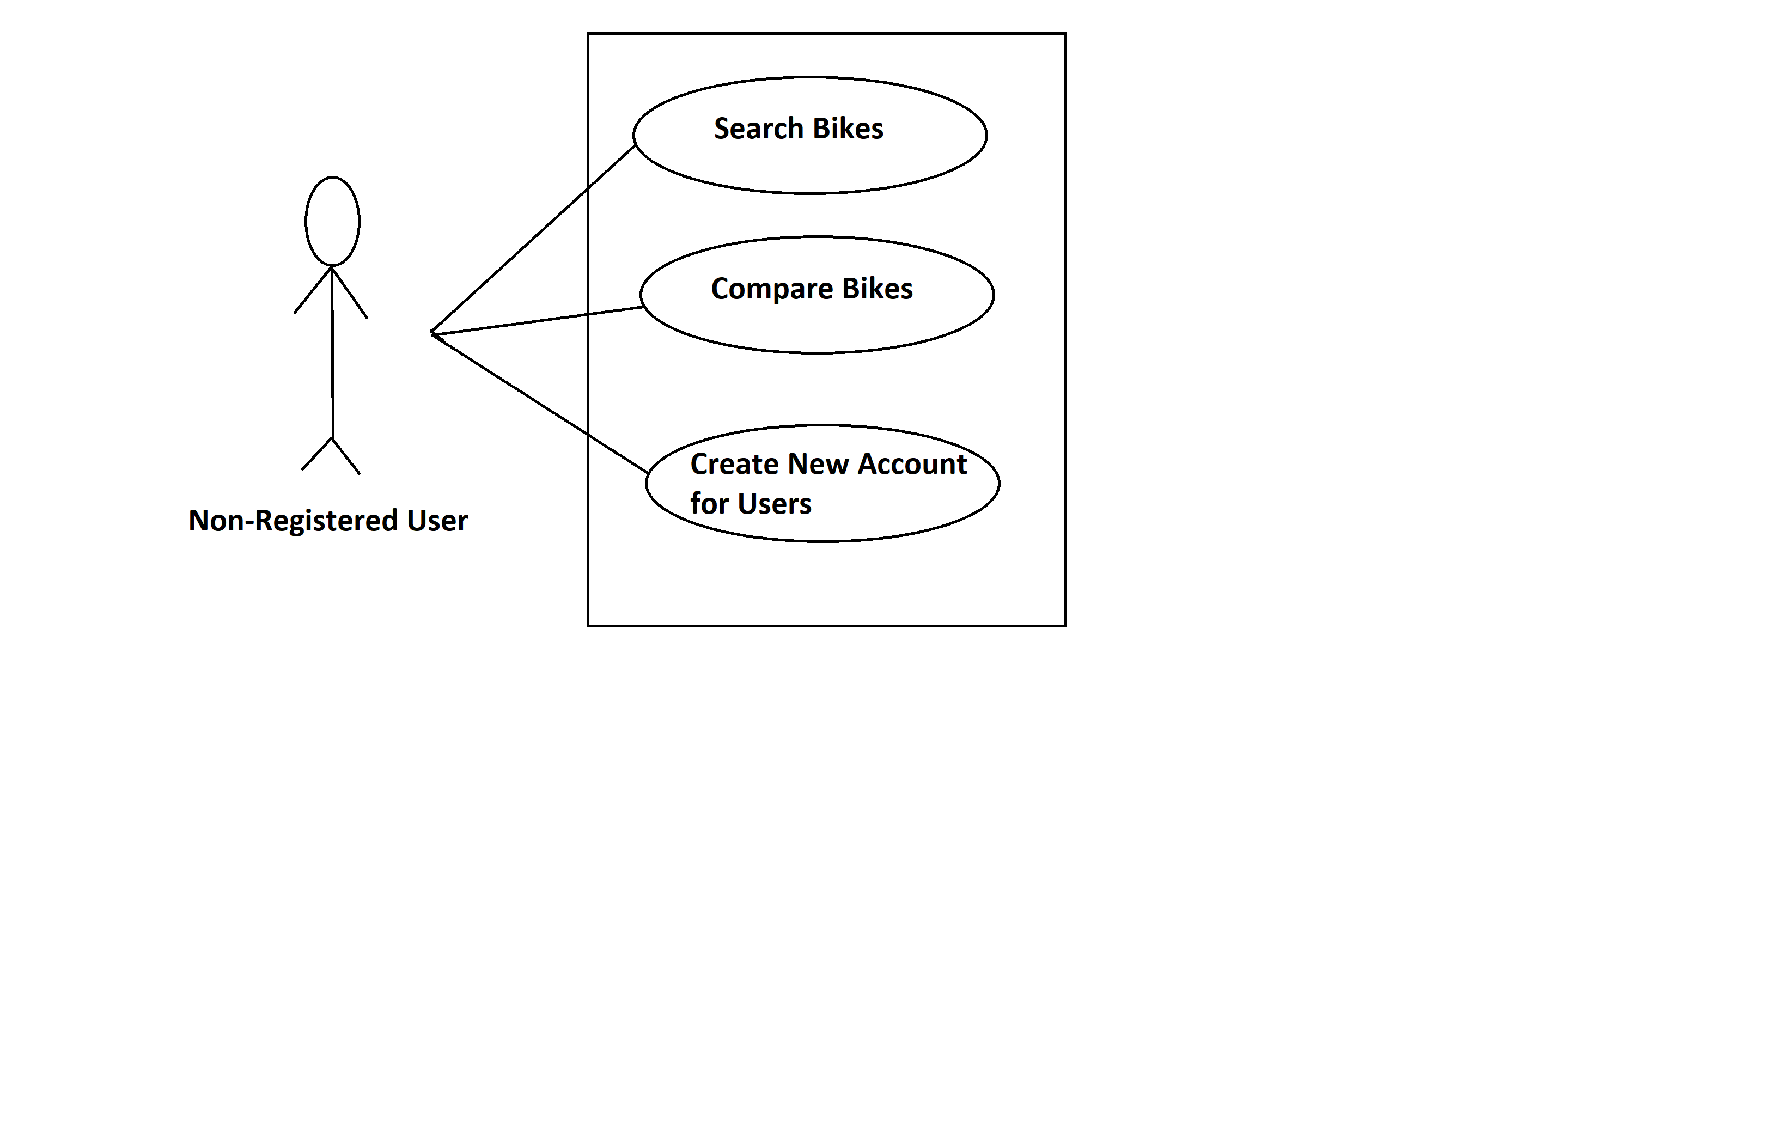

***Fig. Use case diagram for Non-registered Users***

* In Non-registered Users use case diagram ***Non-registered User*** is the Actor.
* ***Non-registered*** User can handle following use cases:
* Search Bikes
* Compare Bikes
* Create New Account

**Registered Users Module:**

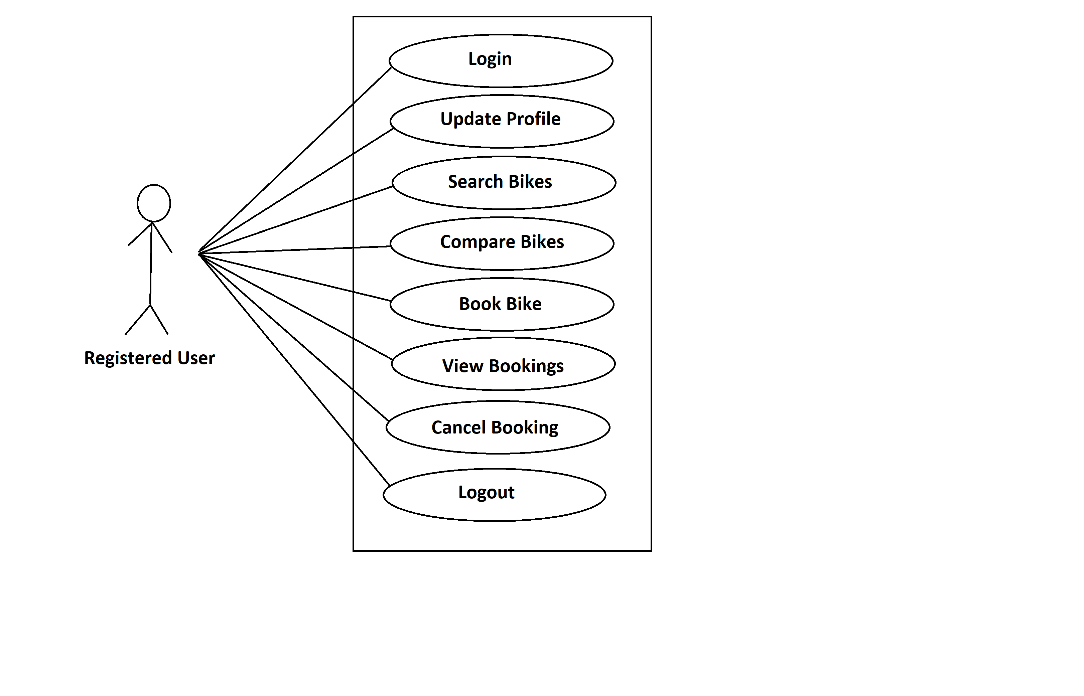

***Fig. Use case diagram for Registered Users***

* In Registered Users use case diagram Registered User is the Actor.
* Registered User can handle following use cases:
* Login
* Update Profile
* Search Bikes
* Compare Bikes
* Book Bike
* View Bookings
* Cancel Booking
* Logout

**Showroom:**

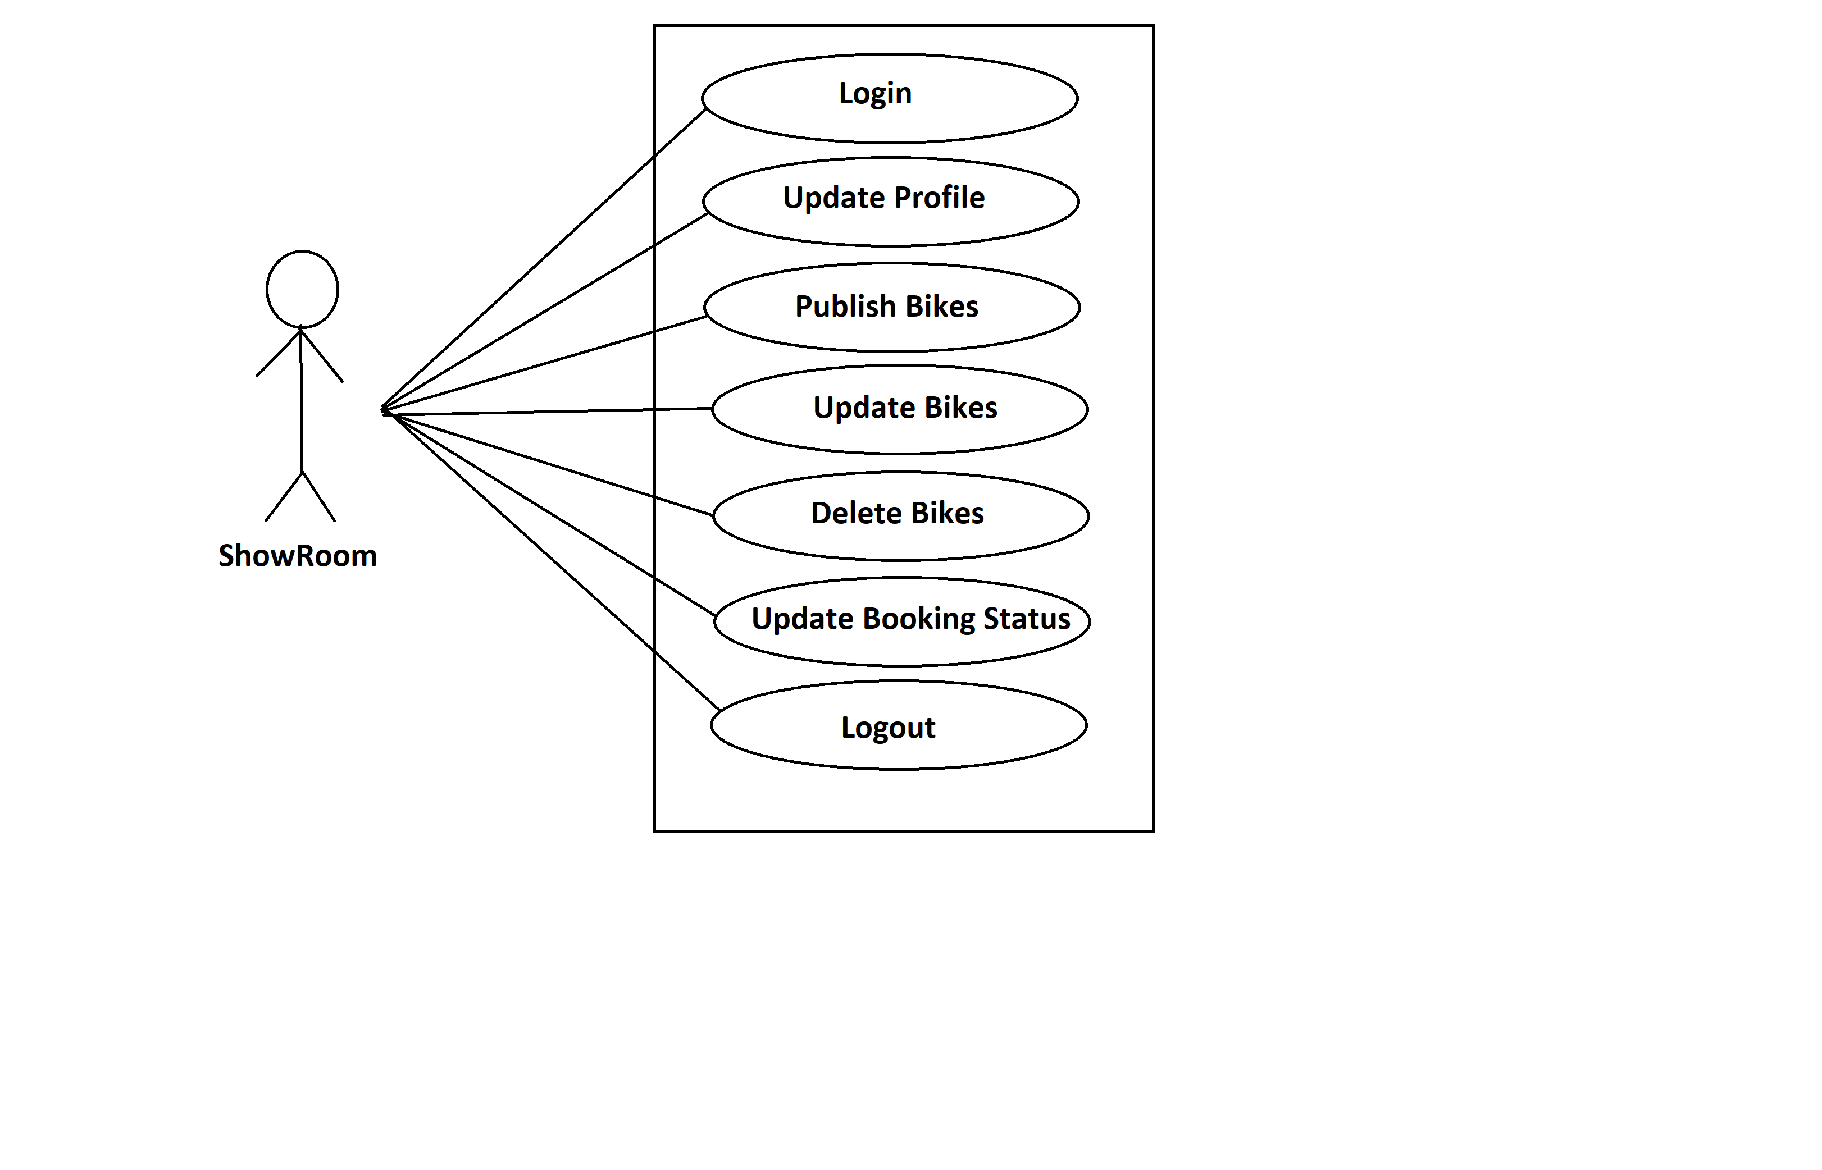

***Fig. Use case diagram for Showroom***

* In the showroom use case diagram the showroom is the Actor.
* showroom can handle following use cases:

✔ Login

✔ Update Profile

✔ Publish Bikes

✔ Update Bikes

✔ Delete Bikes

✔ Update Booking Status

✔ Logout

**Admin:**

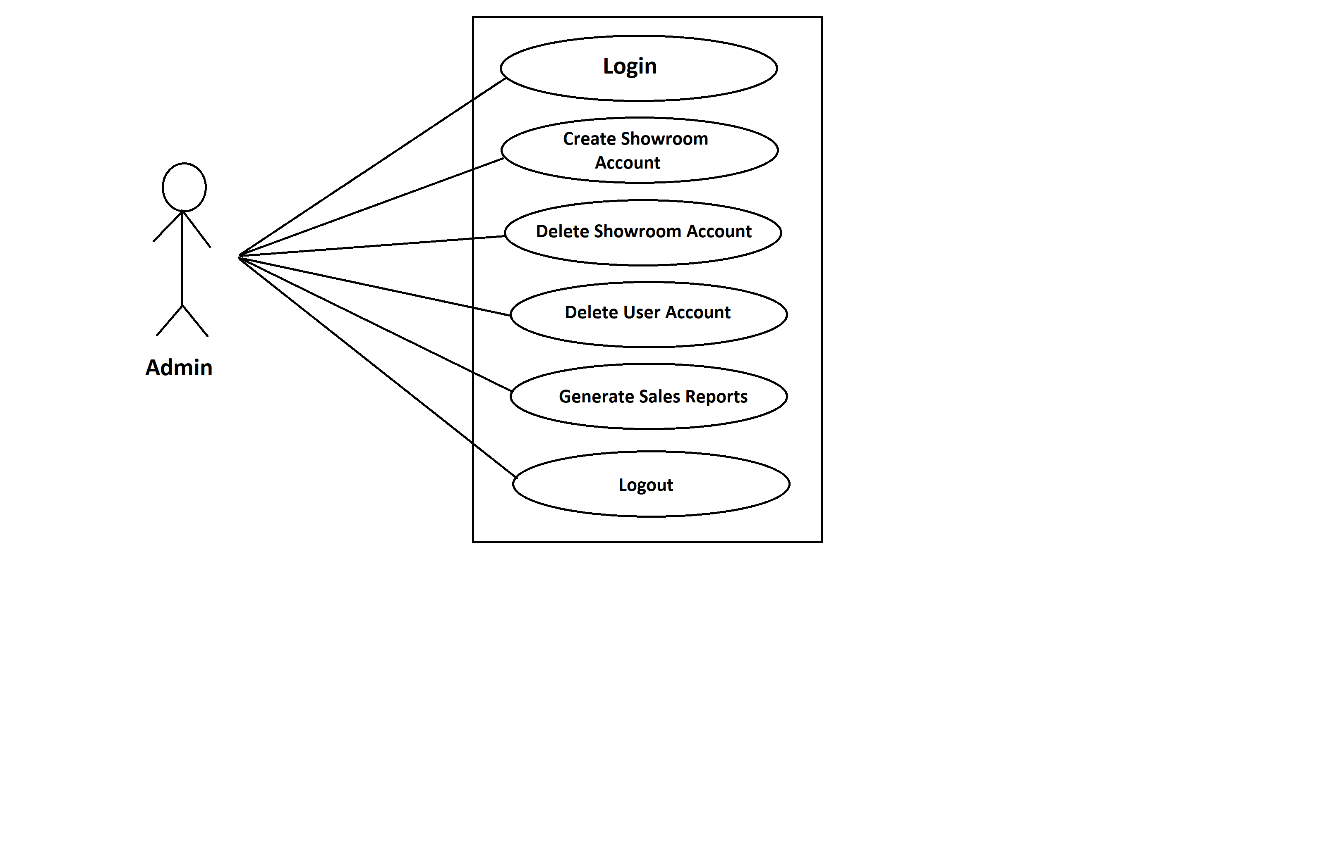

***Fig. Use case diagram for admin***

* In the Admin use case diagram Admin is the Actor.
* Admin can handle following use cases:

✔ Login

✔ Create Showroom Account

✔ Delete Showroom Account

✔ Delete User Account

✔ Generate Sales Reports

✔ Logout